|  |  |  |  |  |
| --- | --- | --- | --- | --- |
| EGC_Black | | Mathematics Essentials 2016  Test 3  Task Weighting: 5% | | |
| Student Name: |  | |  |

Time Allowed: 60 Minutes Total Marks: 60

**Calculators and files are allowed in this test.**

***Answer all of the following questions. Show all working to maximise marks.***

**Question 1**  [4 Marks: 1, 1, 1, 1]

a) If carrots cost $2.76 per Kilogram what is the cost of 5 kg?

b) How many kgs can be bought for $18?

c) If I can jog at 10km/hr how long would it take to jog 5 km?

d) How far would I go in 6 minutes?

**Question 2** [4 marks – 2, 2]

A taxi charges $2.50 plus $1.90 for each km travelled, how much would it cost if you travelled:

a) from to Kalgoorlie to Coolgardie which is 39 km?

b) If I had $20, how many whole kilometres could I travel?

**Question 3** [8 Marks – 2, 1, 1, 2, 1, 1]

The results from a survey on phone ownership are displayed in the two-way table below:

Mobile Phone Owners.

|  |  |  |  |
| --- | --- | --- | --- |
| **Type of Phone** | Male | Female | Total |
| **iPhone** | 36 |  |  |
| **Samsung** |  | 45 |  |
| **Total** | 58 | 95 |  |

a) Complete the above table.

b) How many people own an iPhone?

c) How many males own a Samsung phone?

d) What percentage of males own an iPhone? (Round your answer to the nearest whole number)

e) What fraction of females own a Samsung? (Simplify your answer if possible)

f) Would a line graph be suitable to display this data? Explain why or why not.

**Question 4**  [5 Marks – 1, 1, 1, 2]

The column graph below shows the **average monthly rainfall** in Perth, in mm.



a)Which month had the highest average monthly rainfall?

b)Which month had the lowest average monthly rainfall?

c)What was the average monthly rainfall for April?

d)Estimate thetotal rainfall for the year?

### Question 5 [8 marks: 2, 1, 1, 1, 1, 2]

The formulae for Basic Metabolic Rate are below, giving the result in calories. The weight is measured in kilograms and the height measured in centimetres.

**Calories can be converted to kilojoules by multiplying by 4.182**

Female BMR = 655 + (9.6 x weight) + (1.8 x height) – (4.7 x age) calories

Male BMR = 66 + (13.7 x weight) + (5 x height) – (6.8 x age) calories

Calculate the BMR (in kilojoules) for the following people, showing all your working.

a) A 17 year old male, 172cm tall, weighing 58kg.

b) A 17 year old female, 172cm tall, weighing 58kg.

c) A 54 year old male, 178cm tall, weighing 73kg.

d) An 80 year old female, 168cm tall, weighing 60kg.

e) Compare BMR for males and females. What do you notice?

f) What happens to BMR as people get older? Explain what aspect of the formula causes this.

**Question 6** [5 marks: 3, 2]

Tom has a resting heart rate of 64 beats per minute. How many times would his heart beat in:

a) i) 1 hour ii) 1 day iii) 1 year

b) An average of 70 ml are pumped from the heart each heartbeat.

How much blood is pumped by your heart in :

i) 1 day ii) 1 year

**Question 7** [4 marks: 2, 2]

Your maximum heart rate can be calculated 2 ways:

Method 1 Max Heart Rate = 220 – your age

Method 2 208 – 0.7 X your age

If a person was 56 years old what would their maximum heart rate be, using both methods

Method 1

Method 2

The **target heart rate** for an aerobic workout varies, but as a guide should be between 50% and 75% of your maximum heart rate. Rounding your answers to the nearest whole number, use Method 1 to calculate the range of this person’s target heart rate.

### Question 8 [5 marks: 1, 1, 2, 1]

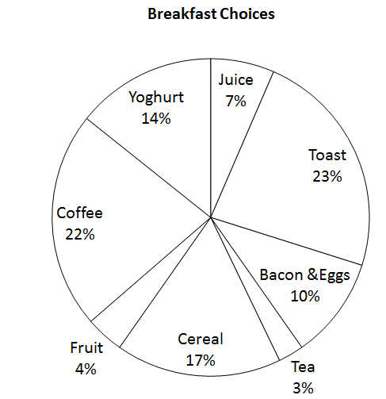The pie graph below displays food choices for breakfast from a group of 77 people.

a) What was the most popular breakfast item?

b) What was the least popular breakfast item?

c) How many people chose cereal as their favourite breakfast food?

d) If 100 people had been surveyed what fraction (simplest form) would have chosen

fruit as their favourite?

### Question 9 [10 marks: 1, 1, 1, 1, 1, 2, 1, 2, ]

John Applecore began his apple orchard in 1996. The first apples were picked in 1999. The graph below shows the harvest for 5 years.

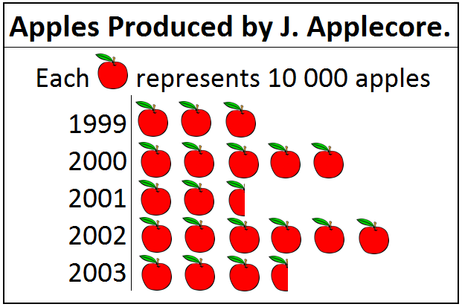

a) What kind of graph is this?

b) In which year was the harvest greatest?

c) What was the harvest in 2003?

d) What was the harvest in 1996?

e) Which year did the harvest increase most over the previous year?

f) What percentage of the apples produced up to 2000, were picked in 1999?

g) How many apples were produced in the first five years?

h) In 2003 John paid Julie 20 cents per apple to pick the complete harvest. How much was she paid?

**Question 10**  [1 mark]

Which type of graph would be best suited for the following data:

|  |  |  |  |  |
| --- | --- | --- | --- | --- |
| Colour Preference | Blue | Red | Green | Yellow |
| Number of Students | 120 | 196 | 215 | 95 |

**Question 11** [2 marks]

Lily is using a recipe that **serves 4** **people**. She is adapting the recipe for **8 people** and has calculated the amount of butter she needs.

Original Recipe 🡪 250 g butter New Recipe 🡪 250 x 8 = 2000g 🡪2 kg

Lily has made a mistake. Check her working and explain where she has made the mistake and correct it to show how much butter she needs to serve 8 people.

### Question 12 [4 marks]

Use the grid below to graph the following information.

Tanya’s height at each birthday from 2 to age 16 are given below, each height being measured to the nearest centimetre.

|  |  |  |  |  |  |  |  |  |  |  |  |  |  |  |  |
| --- | --- | --- | --- | --- | --- | --- | --- | --- | --- | --- | --- | --- | --- | --- | --- |
| Age in years | 2 | 3 | 4 | 5 | 6 | 7 | 8 | 9 | 10 | 11 | 12 | 13 | 14 | 15 | 16 |
| Height  (cm) | 86 | 94 | 103 | 108 | 115 | 121 | 128 | 133 | 140 | 147 | 154 | 158 | 163 | 165 | 166 |

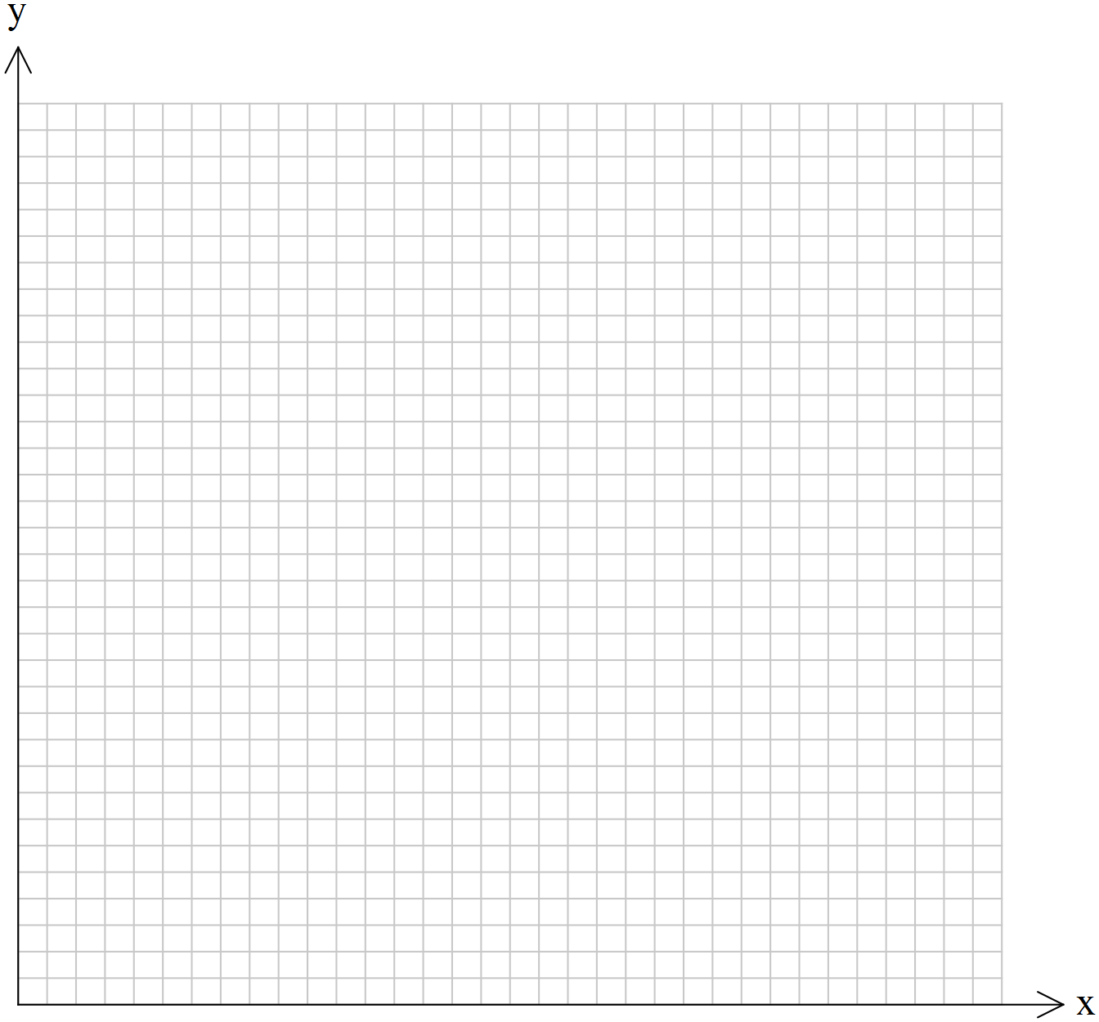

**END OF TEST**